**Project title**

Soccer

**Name of the project**

Soccer Team Database

**Team members**

Huzefa Sadikot

Akshat Shanbhag

Rene Irias

Atreya Raorane

Raj Parekh

**Project Scope and Planning**

Our project is all on a soccer database so all the data provided by us can help scouts(recruiters) to find new players through their performances and availability.

**How will scouts use this database**

When scouts need young players for their team they need player data to see many factors before picking them up for a particular role.

Keys factors that scout can use from the database:-

* Players Stats
* Players playing for which country
* Players team stats
* How many tournaments did the player play
* Players availability

**Logical Data Model**

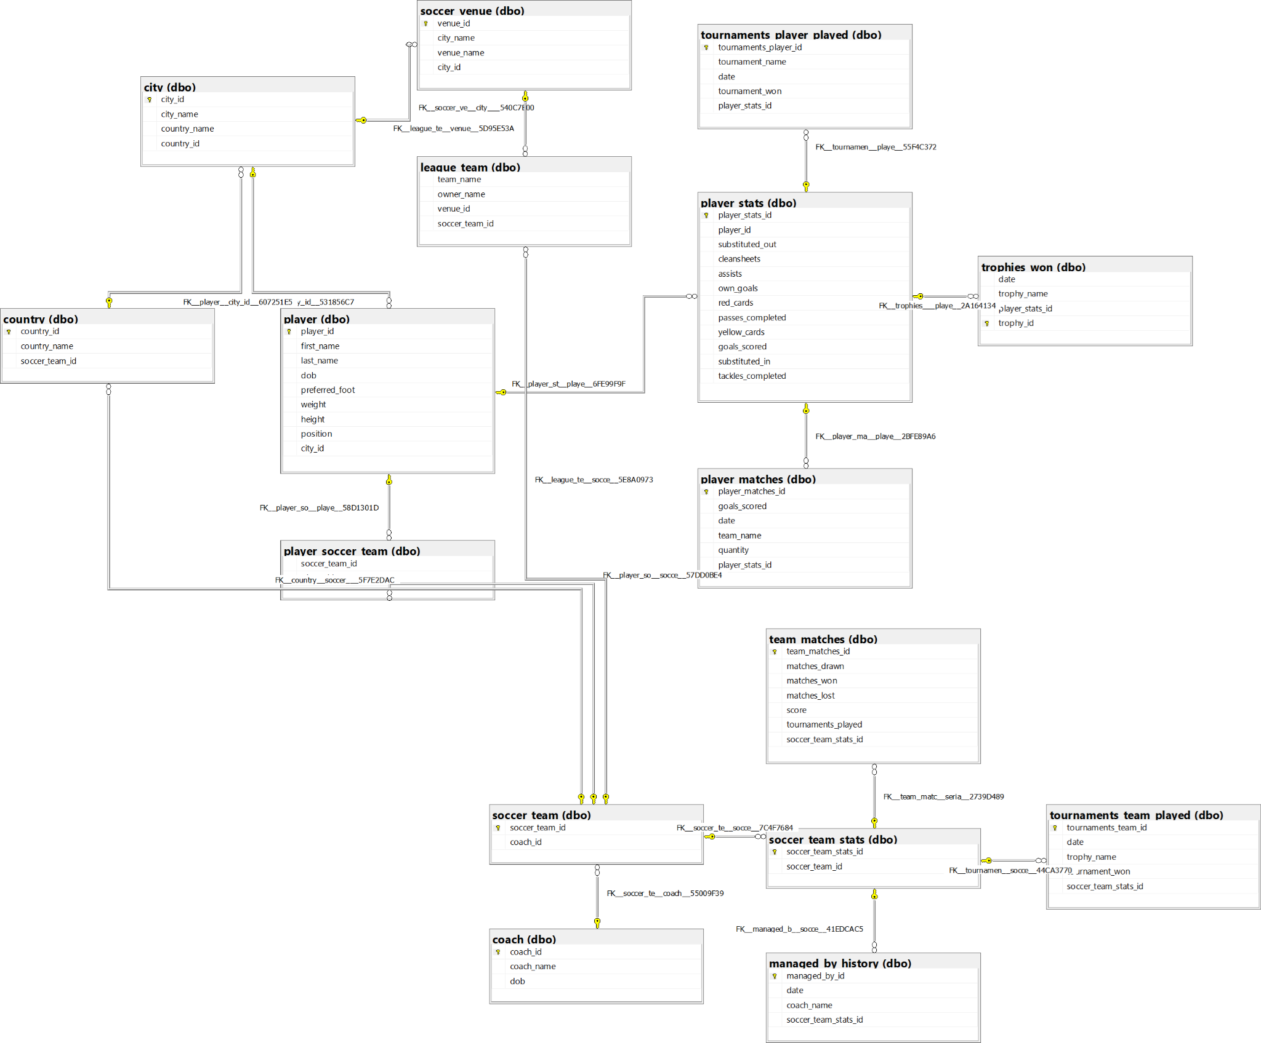

**Create Database and load Data**

**All Database we created are in 2NF**

To create the database the following command is used;

**CREATE DATABASE soccer;**

To load data in the database insert query is used:-

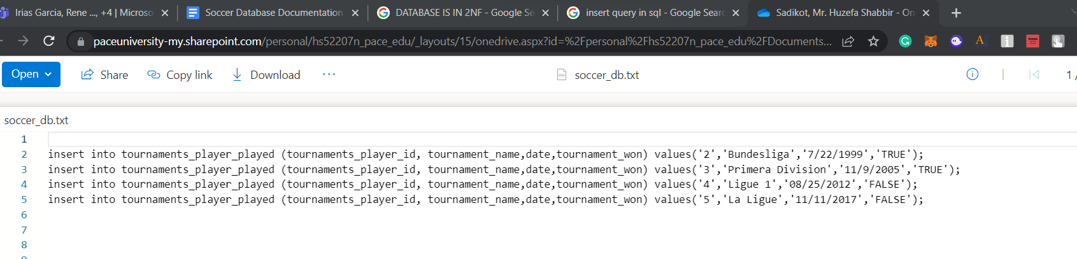

A view can be created for the user to see precise data referring to a specific topic

We have created 3 views

1. Top_Player_Statistics
2. Player_unavailibility_view
3. Young_Player_Statistics

Let us see how to create one view

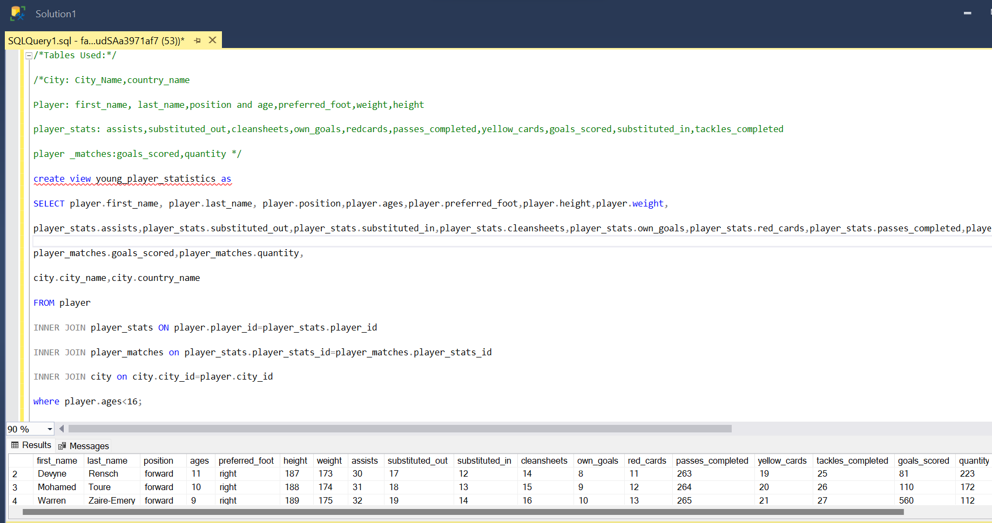

**Report and Visualization**

Create, Insert, and view are the query that we have used for the soccer database

**Create query**

While creating the database for soccer we mainly focused on the primary key, the foreign key of the table created, and the datatypes of the column.

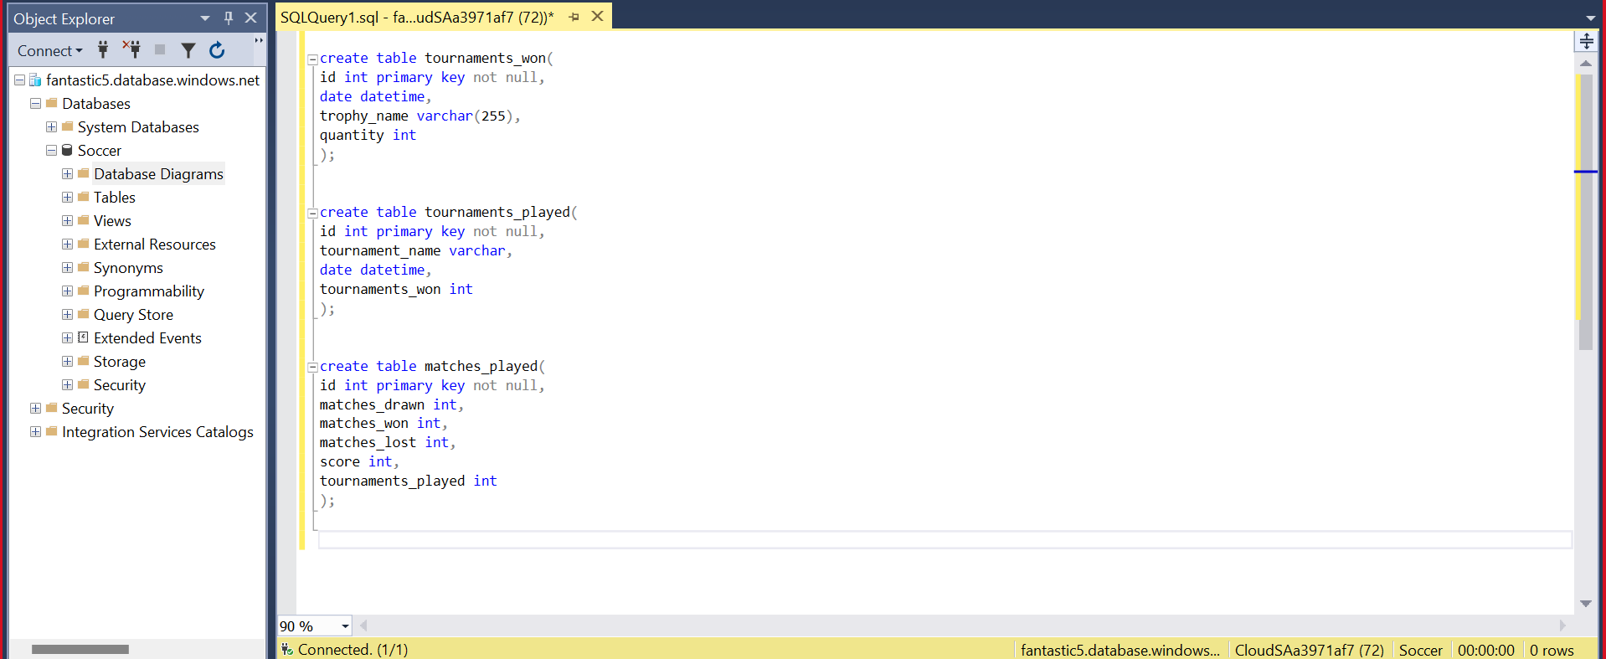

Also, the following queries can be used:

1. **Insert query**: INSERT INTO table_name (column1, column2, column3 ...column) VALUES (value1, value2, value3.....value);
2. **Update Query:** UPDATE table_name SET column1 = value1, column2 = value2, WHERE condition;
3. **Alter Query**:ALTER TABLE table_name ADD column_name datatype;

**Conclusion & Lessons learned**

More data to be added it contains only 5 rows, Can be implemented in docker but it requires WSL( Windows Subsystem for Linux) and docker desktop to run. Hence heavy. Can use AWS but expensive. Thus used azure to deploy the SQL database under the student account using free credits given by azure. Created database in 2NF. Can increase normalization further.